1: Install nginx and run nginx on port number 81
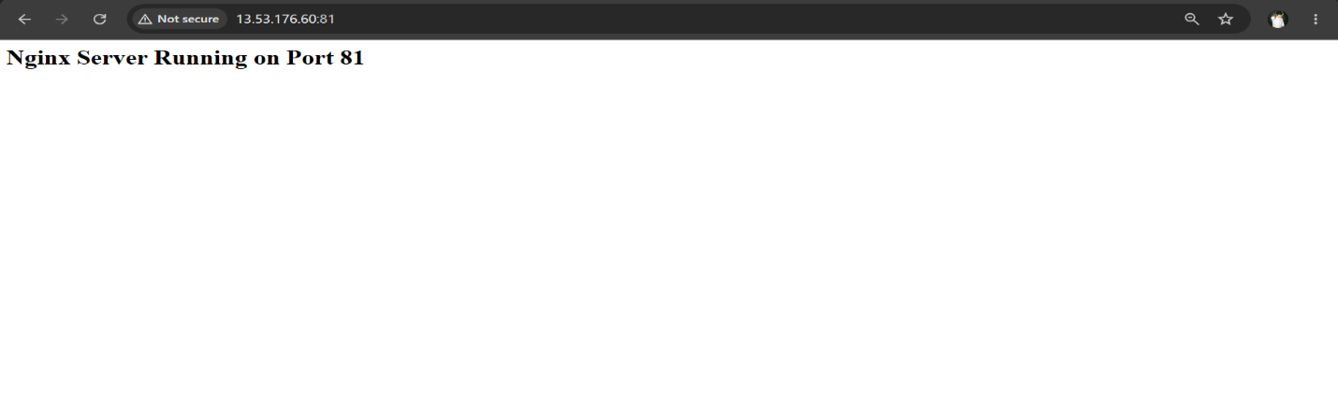
2: Deploy a sample index.html file on nginx.
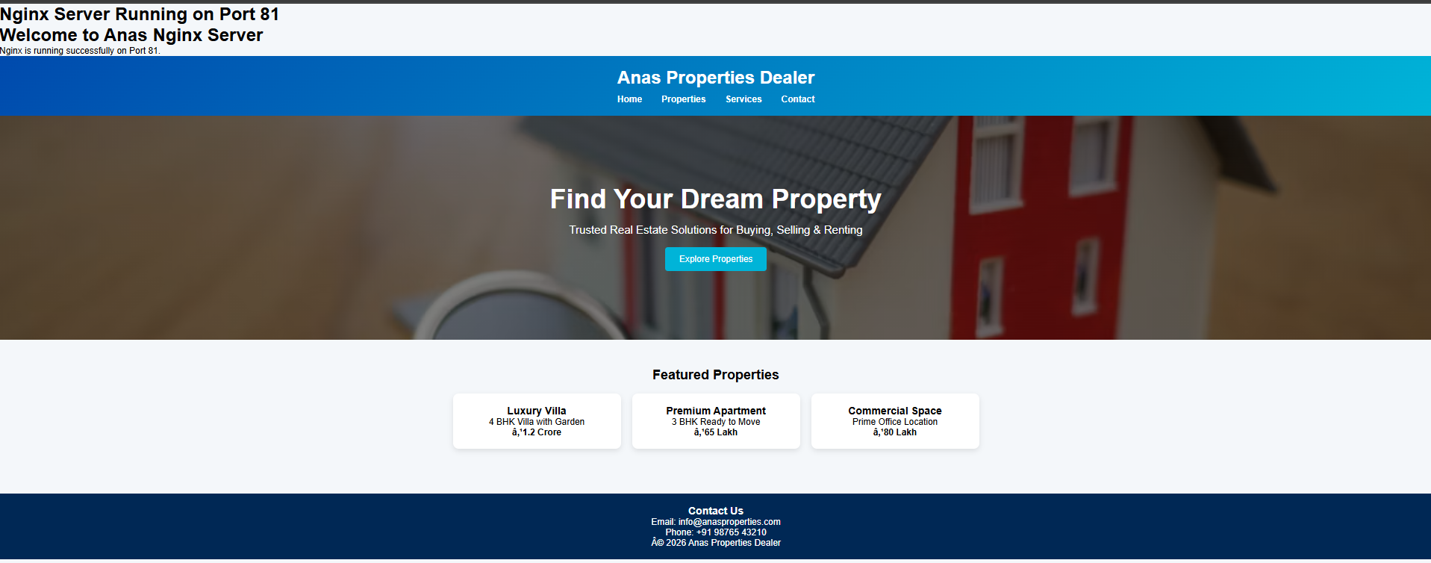
3: Install Apache and run Apache on port number 82

4: Deploy a sample index.html file on Apache

5: Install Apache tomcat on port number 8082
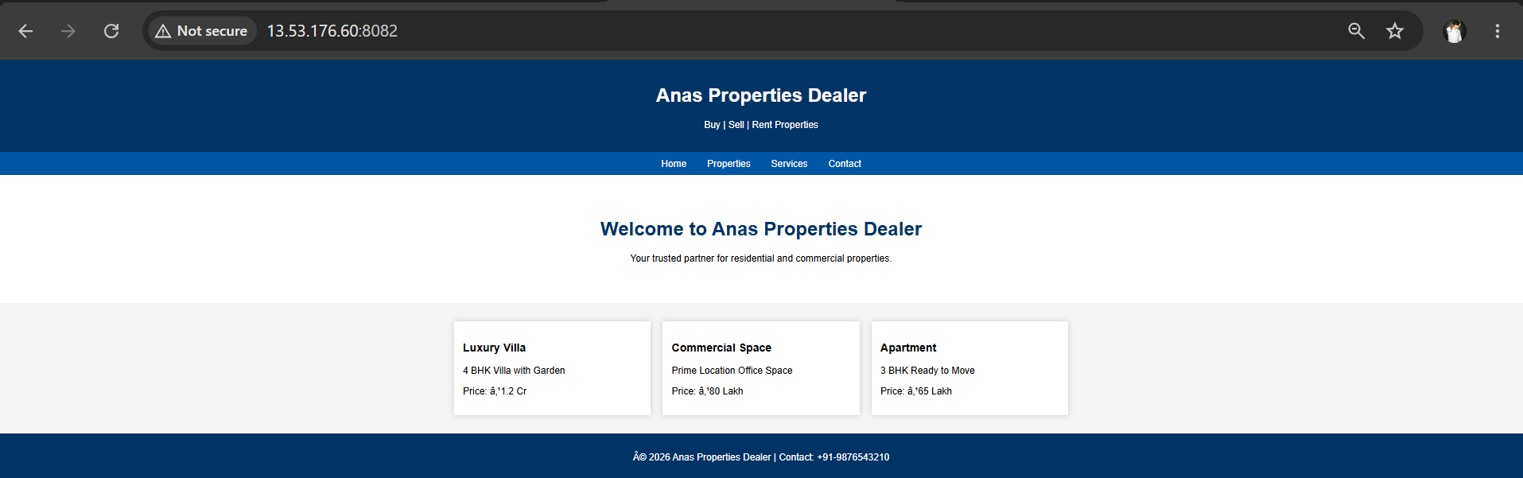
6: Deploy a sample app on webapps
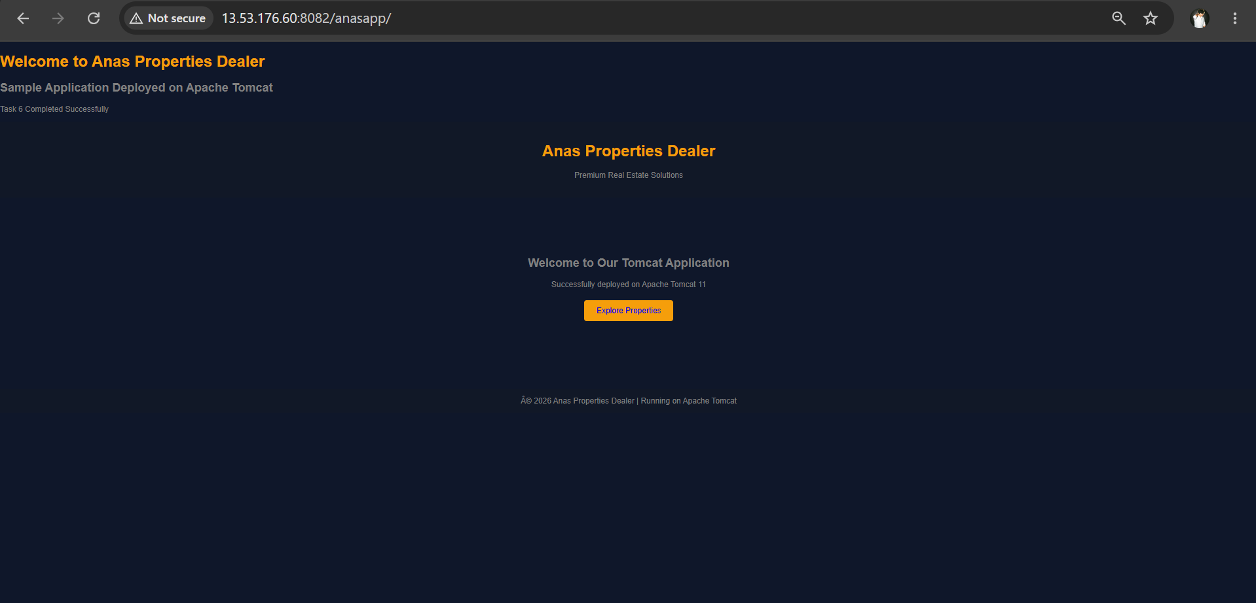
7: Create a tomcat service file for tomcat.
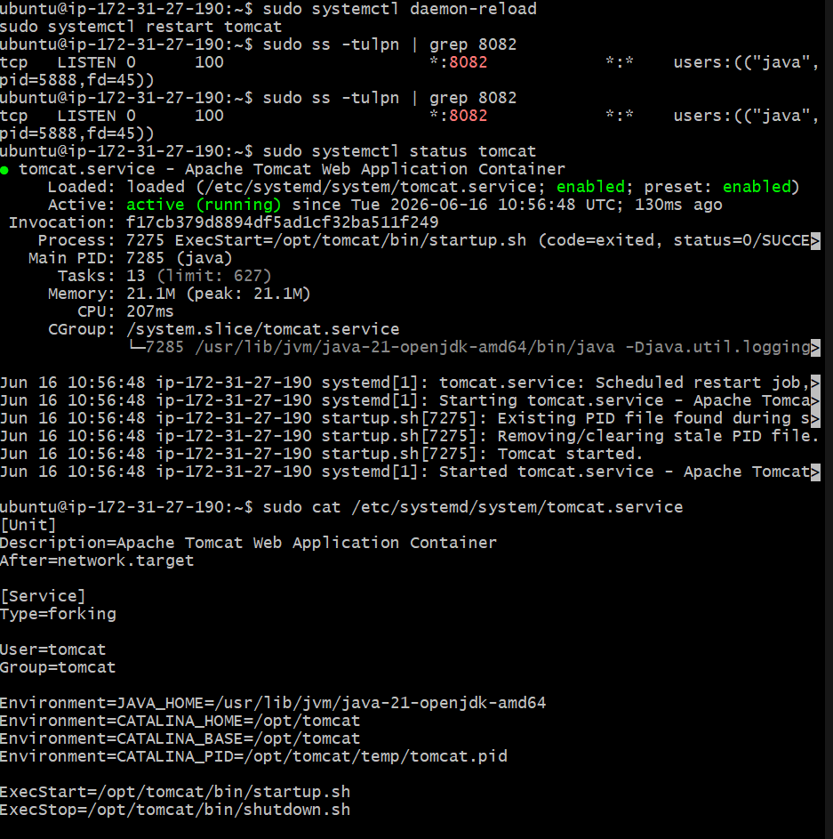
8: Configure HA Proxy server
